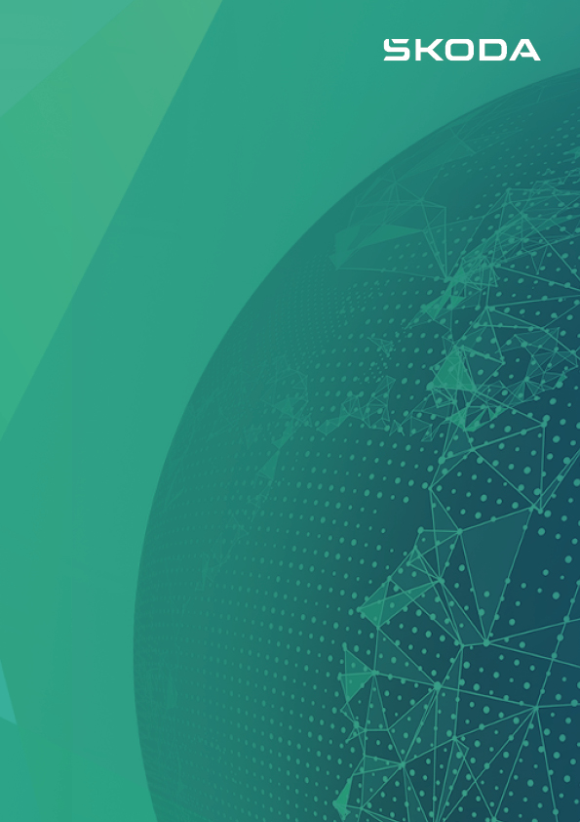
Annual Press Conference 2023
16. 3. 2023

Klaus Zellmer, Škoda Auto CEO
Closing Speech
General Annual Press Conference background
Thank you for your insights from sales and marketing, Martin.
Dear guests,
This was a summary of 2022 for us at Škoda: A year of big challenges - but full of great products, exciting events, and important strategic decisions contributing to the ongoing transformation of our company.
Škoda is ready for the transformation era. And we are delivering!

New world premieres
Our customers in the compact and large segments can look forward to “Superb” new models this year.
First, our Kamiq and Scala will be receiving a comprehensive facelift.
Both cars will receive exterior and interior visual updates – focusing on design and sustainability.
We will also be introducing our all-electric Enyaq in the exclusive Laurin & Klement equipment line. This line epitomises the highest level of comfort and delivers a comprehensive range of equipment as standard. The new Enyaq L&K will also feature lots of technical enhancements.
And, most importantly, our ICE flagships Kodiaq and Superb will receive a complete make over – they will arrive in the second half of 2023 with an attractive design, new technologies and efficient engines, including plug-in hybrid drivetrains.
I’m sure that our customers will love our new models and appreciate the hard work and passion Škodians put into every detail of these cars.
This brings me to one more important item for 2023: In a few weeks, we’ll be sharing more details on our updated and accelerated electrification roadmap. I’m already looking forward to it!
Let me end the official part of today's APC with some important news before we move on to the Q&A session.

ASEAN
At the beginning, I mentioned that internationalisation is a key element of our strategy and we’re always exploring new growth markets, new opportunities.
That’s why I’m very pleased to announce that Škoda will be taking over the strategic lead for the entire Brand Group Volume’s future expansion across the ASEAN region.
We’ll be maximizing the region’s huge growth potential for the Volkswagen Group with a clear strategy and long-term vision.
The ASEAN region is growing by 8% a year – that’s a huge potential. And the automotive market is expected to be more than 4.1 million vehicles in 2030.
With an estimated electrification rate of 30% by the beginning of the next decade, the future in these markets also lies with electric vehicles.
We want to become a strong player in this region with a market share of over 5% for our volume brands.
As outlined, we are getting ready for further expansion in Vietnam. The country will be our gateway to the ASEAN region.
The responsibility for the region testifies to the Group’s trust and confidence in the expertise of the Škoda team.

Middle East
We’re confident that our success story in India will help us succeed in the equally diverse ASEAN region.
India is a key market in our internationalisation plans. We plan to turn it into an export hub – following a clear strategy.
We began exporting our Škoda Kushaq models from India to the Gulf States last October. This makes the Middle East the first export region for our India-produced models.
As we are anticipating rapid growth there, we’ve recently taken another step towards expanding our global footprint by joining Audi Volkswagen Middle East.
The existing sales structure opens up additional growth opportunities, and I’m sure that our products will be successful there, as well.

General APC background
Dear guests,
As you can see, we have a lot on our agenda, and we’re following a clear strategy.
2023 will be a year of new products, new milestones towards electrification and internationalisation. I’m already looking forward to it. And now, we’ll be happy to take any questions you have.
May I ask my Board colleagues as well as Mr. Lacina to join me on stage.

